Leveling-Up Your Pedagogy:
Understanding Video Game Construction in the School Library

Kandise Salerno
University of Alberta
551 Education South
Canada
kperry@ualberta.ca

Abstract
As a teacher and technology coach I have experienced firsthand the wonder of students playing and constructing video games, as games facilitate incredibly good learning experiences (Egenfeldt-Nielsen, Smith, & Tosca, 2012; Papert, 1980; Salen, 2007; Shaffer, 2006; Squire, 2006, 2011). Student based game construction has the potential to transform the learner and further meet the participatory demands of 21st century learning. This paper will provide teacher-librarians with a detailed account of my own experiences with video game construction in school environments. As a guiding framework, both Miller, Shell, Khandaker and Soh’s (2010) input-process-outcome game cycle and Koehler and Mishra’s (2008; 2009) Technological, Pedagogical and Content Knowledge (TPACK) framework will be applied to support this video game construction exploration.
Keywords: Video games, technology, technology integration, pedagogy, maker movement
Gaming in the Classroom
As an educator and technology coach concerned about the potential of digital technologies in learning environments, video game construction represents the most immersive and meaningful use of technology that I have ever experienced. The potential of video game construction is further enhanced when compared to the present offering of video games located in today’s classrooms. In fact, most educational video games, such as Math Blaster or BrainPOP continue to facilitate a relatively poor learning experience (Chee & Tan, 2012; Egenfeldt-Nielsen, 2007; Egenfeldt-Nielsen et al., 2012; Foster, 2008; Gaydos & Squire, 2012; Gee 2005, 2007a; Rice, 2007). The problem lies with perception, whereas educational video games continue to be perceived as teaching machines, devices that produce a drill and practice or more aptly identified as a drill and kill experience.
Video game construction represents a contextually different kind of experience, whereas students learn and build through a constructionist (Papert, 1980), learning by doing experience. This gaming experience generally produces higher-level thinking (Salen, 2007), analytic and conceptual thinking (Clark & Sheridan, 2010), reflection and evaluation (Dickey, 2006) and a context to learn about and with technology (Kafai, Ching & Marshall, 1997). Most educational video games such as Math Blaster struggle to move beyond a behavioristic experience that is framed through simply shooting down numbers to solve simple algorithums. In fact, for many children they become disengaged when playing educational video games, because they are vastly different from the games they play at home or at the arcade. In fact, most of the games located at the local video game store produce better learning experiences as compared to the games that are located at school (Gee, 2005, 2007a; Egenfeldt-Nielsen, Smith, Tosca, 2012; McGonigal, 2011; Papert, 1980; Prensky, 2007; Salen & Zimmerman, 2004; Shaffer, 2006; Squire, 2011).
By identifing the potential defincieis that are situated in educational video games, it seems imperative that educators become orientated with video game construction programs to faciliate a shift in focus. This paper will present one perspective regarding video game construction and how it was integrated into a school environment. Resources and peagogical application will be identified throughout.
A Teacher Immersed in Video Game Construction
My first introduction with video game construction was through a collaborative project with the Center for Mathematics, Science and Technology Education (CMASTE) and a local junior high school. In working with three grade seven teachers and their classes we developed a video game construction project centered on the Canadian fur trade (grade seven social studies curricular outcome). Certainly this project presented some challenges, as it was different from the more traditional pedagogical approaches often used to teach the Canadian fur trade. The students, however, were not only highly motivated and engaged in the design project, they also achieved a comprehensive understanding of the topic through the multiple narratives they constructed in the game. Through this project, we came to understand that game construction presents multiple paths of understanding that allows students to understand the curricular topic through multiple lenses, while also understanding the geography and time period of the Canadian fur trade.
Although we provided about eight hours to complete this student-based game construction project, many of the students spent over 100 hours of their own time, building and adding to their video game. In essence they were immersed in the curricular topic over many hours, which means their experiences reciprocally established an in-depth and authentic understanding of the topic. Interestingly, once the teachers introduced game construction as a viable tool to use for learning, many of the students felt confident to apply game construction to other topics and projects outside the realm of social studies. Some students constructed a video game for a book review language arts project, others created a roller coaster video game in response to a math project and others recreated a particular ecosystem for a science project. These video games and the act of participating in game construction became an immersive part of the school culture.
Additionally, the Faculty of Education at the University of Alberta intuitively developed an undergraduate level course that explores game construction as a pedagogical application for learning. As a guest lecturer for this course, I discuss my own experiences with game construction in middle school environments. To support this analysis I apply Miller, Shell, Khandaker and Soh’s (2010) input-process-outcome game cycle (figure one), which clarifies the overarching process that is experienced for both the teacher and the student while immersed in game construction. The following represents some of my personal narratives that transpire during game construction.
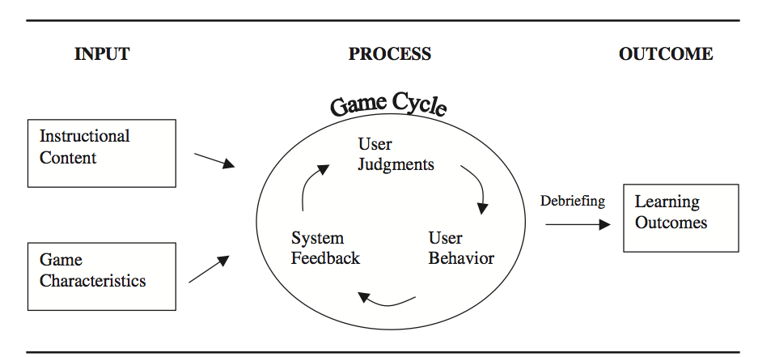
Figure 1: Input-Process-Outcome Game Cycle (Miller et al., 2010)
Input: Instructional Content
This is perhaps the most difficult stage for those planning to implement video game construction into the school environment, particularly as there is a tight balance between providing a learning by doing experience, while still meeting the content demands of the school curricula. To develop a sense of clarity regarding the integration of video game construction into the learning environment, I utilize TPACK (Koehler & Mishra, 2008; 2009), a technology framework that suggests a balance between technology, pedagogy and content knowledge. As seen in figure two, each of the three knowledge forms is in balance with each other, suggesting they must work together when designing a 21st century lesson. Often digital technologies represent the driving force behind the choices made in the classroom, whereas the pedagogical and content applications become secondary elements. However, TPACK realigns the importance and balance of all three knowledge forms, and by doing so, the integration of the technology will be more purposeful and more aligned with the required content.

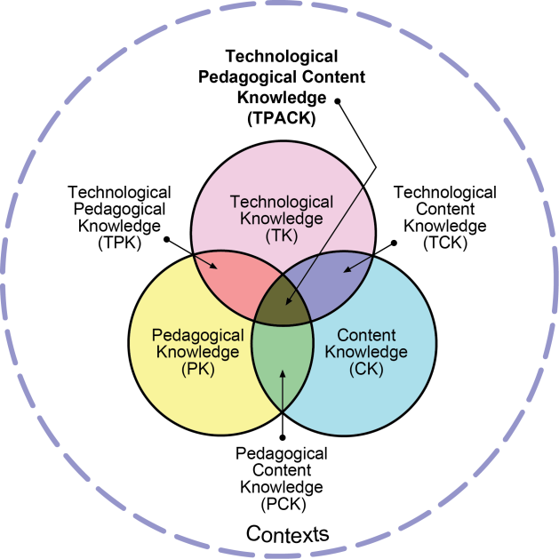

Figure 2: Technological Pedagogical Content Knowledge (TPACK) Framework (Koehler & Mishra, 2008).
In applying TPACK to video game construction, generally the first choice is to select the video game construction software. Over the past few years a variety of choices have been made available, and as an educator my two favorite choices are Scratch and Kodu. Scratch (figure three) is a simple game authoring tool that introduces students to the basics of computer language, whereas they are provided building blocks in a drag and drop format that builds a game through a cause and effect relationship. Kodu (figure four) is a relatively new, real-time 3D gaming environment, which was formally known as Boku. The game program can run on either a Windows operating system or an Xbox console. MacLaurin (2011) suggests that Kodu “seeks to lower the barrier of entry for new programmers by presenting a radically simplified programming model which nevertheless has significant expressive power” (p. 241). The program uses a graphics-based coding selection, in which gamers select certain images from the wheel to perform certain tasks in the game. Both programs are relatively easy to use, easily accessible and an excellent tool to introduce game construction into the classroom.

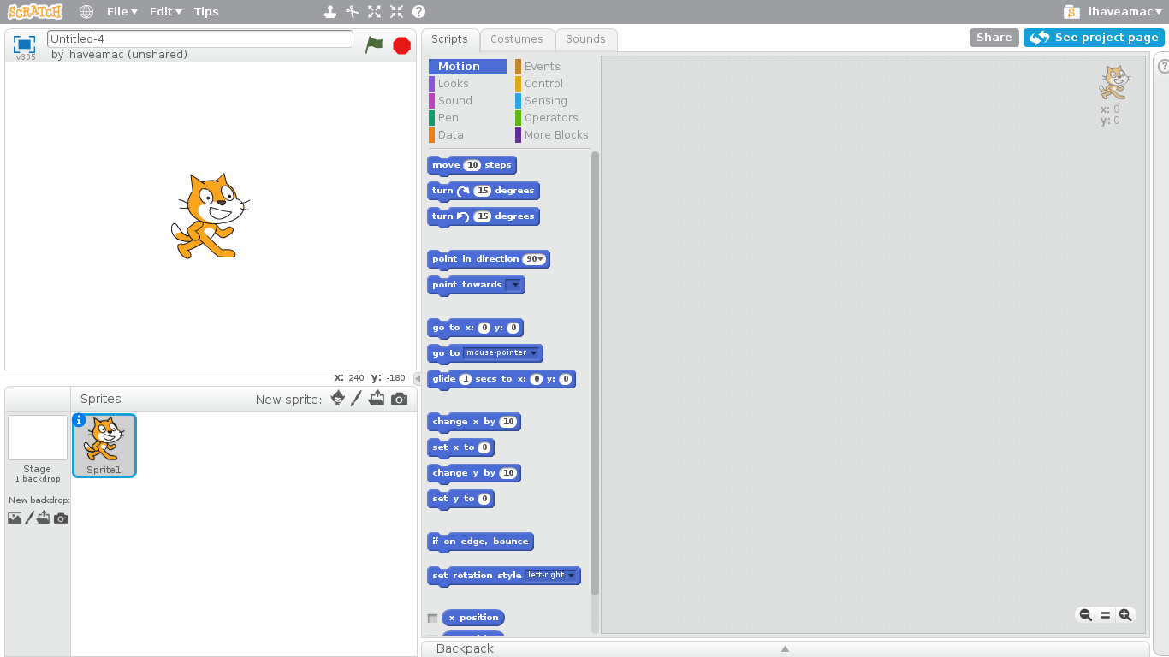

Figure 3: Screenshot of the program language in Scratch
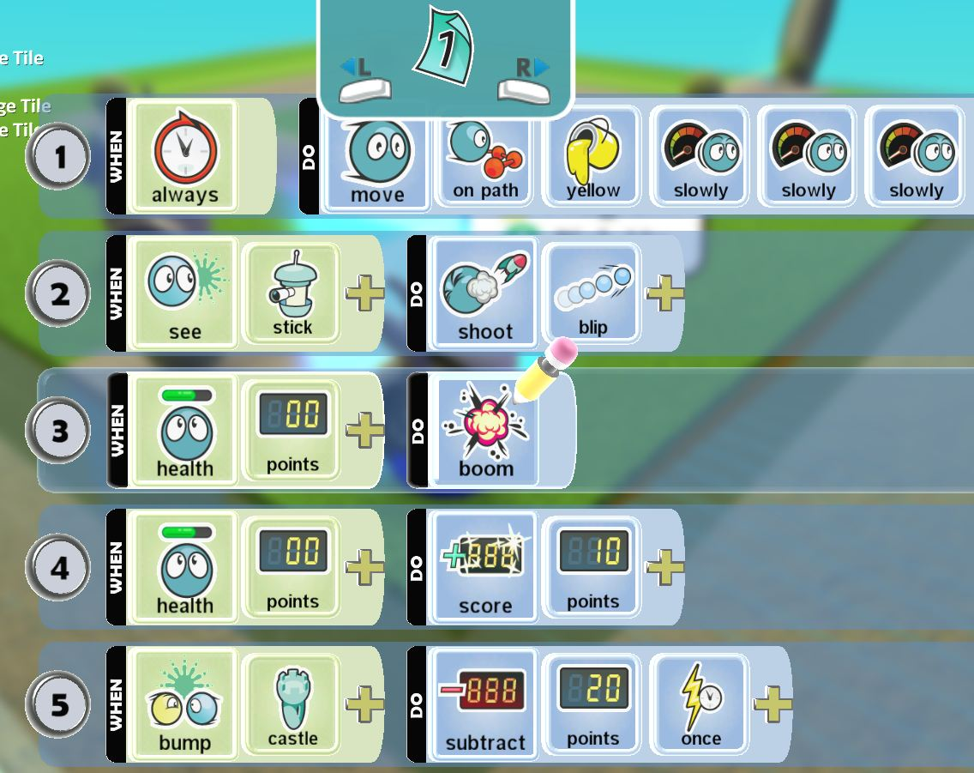

Figure 4: Screenshot of the landscape found in the Kodu game construction program
In considering the second knowledge form of TPACK, content, it is wise to identify an outcome that has the flexibility to extend into other content areas and lends well to project based learning. In working with a group of grade seven social studies teachers, we purposely choose the Canadian fur trade as the content area, particularly as the children would have the freedom to construct a narrative about their interpretation of the topic. We also realized that their game could potentially continue into subsequent levels, by retelling other historical aspects of Canadian history. Not only did this choice of curricula allow the students to level-up in their game, but it also allowed for a cross collaboration between subject areas. We were able to have the Language Arts teacher become involved as the narratives that were located in the student’s game were powerful indicators of a non-linear writing format.
The remaining knowledge form of TPACK, pedagogy is perhaps the most difficult to conceptualize, particularly if video game construction is a relatively foreign entity. Table one represents some guiding questions and potential responses that might help form the pedagogy of the video game construction unit.
Table 1: Questions and Responses for Instructional Content
Question | Potential Response
What teaching takes place before, during and after the game construction project? | I have done this both through front loading the content, with the continued suggestion to the students that they would be designing a video game at the end of the unit. I have also gradually released the information to the students, where I taught a little, and they designed a little.
What is your time frame? | This depends on how you will integrate game construction for the students. I have done gaming days, where the students are provided the entire day to build their video game. So after about six weeks of learning the content, we provided one or two gaming days to complete their entire game. Alternatively, the students would be provided two hours at a time to continue to build their game throughout the unit. Providing less than an hour or two at a time is difficult, as it doesn’t allow the students think deeply about their game.
Where is the game construction going to take place? | I also like an expansive place for the students to build, where there is a place for the students to spread out their planning materials such as maps, characters descriptions, stories, and research. Often this space is in the computer lab or the school library.
How will you communicate this project to parents and the community, particularly those who are concerned? | Depending on the school community, a letter describing the project could go home, or a parent night that describes the project to the parent community.
How do you plan on grouping the students? | I always like to group the students, usually no less than two but no more than three. Creating groups with more than three students generally makes one of the students become disengaged from the process, as it is difficult to fit more than three students around a computer. In addition, depending upon the school community and students, it is good to have a gamer in each group, as they understand the overarching narrative located in a game and will be able to help the rest of the group in the construction process.

In applying TPACK to the initial input stage of video game construction, it becomes clear some of the essential components that need to be considered. Please see appendix one to view an outline of a game construction unit.
Input: Game Characteristics
Video game construction demands a different kind of narrative experience for students to consider, particularly as it is a non-linear representation of a story. For some students who play games on a regular basis, they will often have an internalized understanding of the rules and characteristics of a video game. But, for other students, video games might be a foreign artifact. Consider how difficult it might be for a student if they were given an assignment to write a comic, but had never seen or read a comic before. The same is true for a student who has never seen or played a video game. Table two represents some questions and responses that might clarify the game characteristics to both teachers and students.
Table 2: Questions and Responses for Game Characteristics
Question | Potential Response
What about non-gamers? How will you orientate them to ensure they understand the narrative and mechanics of a video game? | I like to show and play some mini-games to the students, as they are short representations of a video game. We then discuss some of the essential elements that are located in the mini-game. I also provide an exploratory day for the students to become orientated with the game construction program. This way they feel more confident with the program, and also with the basic capabilities located in the game. For example, Kodu has a limited number of characters, which allows students a conceptual understanding of what they are working with when planning the game.
What is the challenge of the game? | When students are planning the characteristics of their game, they can often forget that there should be some end point to their game. Certainly there are plenty of infinite video games on the market, consider Tetris, a game that continues until you can no longer stack the blocks quick enough. However I think it is important for students to design a finite game, an end point where the gamer knows they have succeeded in the game. As the students are designing their game, you want to provide strategies of how a game can be won, including collecting enough points, getting to a certain point, achieving a certain status, etc.
How will the students prepare for the game experience? Will they need to create a map, Write a narrative? Chart out their ideas? | Although this preparation depends upon how the game construction unit is going to be implemented, such as gaming throughout the unit or gaming at the end of the unit. Regardless, it is helpful for the students to have completed some preliminary work prior to jumping into game construction. I find the most helpful tool is providing a large piece of paper to the students and ask them to create a preliminary map of their game. Here the students will design the overarching flow of their game, the cause and effect relationships that will transpire and the potential rationale for conquering the game. When the students have completed their map, I ask them to walk me through the game. This verbal dialogue often provides the opportunity for the students to debug any initial issues they may have in the game. In addition to the map, I also ask the students to further develop their characters, the relationships that transpire between them, and the potential scenarios that will occur amongst the characters and the world they have constructed.

Please see appendix two to view a planning document of how students might design their video game.
Process: Game Cycle
At this point, you have successfully planned a game construction unit. The second phase of Miller et al. (2010) game cycle identifies the act of constructing a video game as the students are generally situated in front of a computer programming and debugging their games. This is perhaps the most exciting phase for both the students and the teacher, as the student’s ideas move from an abstract concept to a concrete representation.
As noted earlier, it is best to have a large open space for the students to program, often a computer lab or the school library. When we enter the computer space, we also rebrand it as our arcade, which changes the perception of the students. I also encourage the students to collaborate with each other, ask each other questions and play each other’s games. Although the amount of time that can be used to program varies depending on how complex you would like the game to be, a minimum of six to seven hours is required. Table three represents some questions and responses that might clarify the game cycle.
Table 3: Questions and Responses for the Game Cycle
Question | Potential Response
What kind of feedback will be given to the student(s)? (Immediate and brief, delayed brief, immediate elaborative, delayed elaborative). | The only kind of feedback I provide to the students is situated in the content of the game. Does the game make sense? Is there enough description in the game so I can travel from one point to the next? Is there content in the game? Often students become wrapped up in very minute details that have no consequence to the game, such as designing an elaborate castle that has no purpose in the game. As a teacher my role is to reinforce the details of their game, and to play their games throughout the process. However, as for the programming I let the students work through any debugging issues. Generally in most classes there will be a few very knowledgeable students that understand how to program video games and are eager to demonstrate their gaming capabilities. As a class we recognize them as our gaming ninjas and the students request their help when needed. This presents an excellent opportunity for the students to support each other in a very collaborative experience.
What will be the role of the teacher while the students are building their games? | Throughout a gaming period, whether it is for an hour or for an entire day, I always provide check points for the students. “By the end of our class today you should have your landscape designed.” During the gaming period, I also ask the students to sign up for at least one gaming consultation session. This consultation is a time that I will sit down with the group and discuss their game. I will likely play the game and the students will provide a running a narrative of pieces of information that might be missing or not working. The students appreciate a planned consultation period, because they can get ready for their consultation and have an understanding of what they are going to showcase. During the game construction unit, I also implement play moments where the students will have the opportunity to play each other’s games. After playing the game, I ask the students to provide some constructive feedback about areas of success and areas to work on. These play moments are crucial to ensure the games have purpose and meaning and generally students provide excellent constructive feedback.
What will you do if the students become off task and/or disengaged? | As in any classroom experience, not all students will enjoy and be motivated to participate in the game construction unit. Although, most students are incredibly engaged and motivated to participate, some find the experience counterintuitive to the more traditional learning experiences they have come to expect. I ask all the students to give gaming a chance, and at times putting a more hesitant student with an enthusiastic gamer helps motivate the process. However, if the student still does not respond to the game construction experience, they can choose to participate in an alternate activity in future gaming units.

Outcome: Learning and Assessment
At this point in the game construction unit, the students have completed their video games or they will continue to work on them outside the context of school. For many students they will find game development to be a revolving process, as they may never feel completely satisfied with their game. Certainly a video game is contextually different from a book report, a math exam or a written narrative, which makes the overall assessment of a video game complex. Table four represents some questions and responses that might clarify this last stage of the game construction cycle.
Table 4: Questions and Responses for Learning and Assessment
Question | Potential Response
How do you plan on assessing the video game? What will you assess? What would you consider a benchmark of an exceptional game? How will you assign a mark? What is the weight of the mark? | For most teachers, some form of assessment needs to be provided for projects and assignments completed at school. In appendix three you will find a rubric that was created for a game construction unit. You will notice that the content is weighted the most, as this was the overarching goal of the project. It is also important to consider if you want to assess the student’s game construction skills. Certainly if the game is filed with bugs, it might be difficult to assess the game, or simply play the game, but is this a skill that is relevant to the unit? Perhaps a separate ICT outcome that identifies their ability to program might be appropriate. When I assess the video games, I always ask the students to play the games for me first. The students generally provide a running narrative throughout the game, which is helpful especially is something is not working in the game. I will also play the games independently.
How will you evaluate the game construction project? | The biggest question once the game construction unit has completed is, did my student learn the content? Certainly, my personal experience would attest to the strong learning experiences derived from game construction, however this will need to be a personal reflection. Student evaluations are an additional feature to further understand what the students enjoyed about the process and what they would change in the future.
What will you do with the games once they are complete? | Student constructed video games can provide an excellent repository for forthcoming years. Students enjoy playing other students video games, and by doing so they might further understand the content and the basic mechanics of a video game. In addition, there are some excellent game sites where your student’s games can be shared. Kodu has a game lab, where student games can be shared and uploaded for others to play. In addition, if students have to write a final exam, I always encourage them to play each other’s games before the exam to review the material.

Conclusion
As video game construction continues to be introduced into learning spaces, it is important to consider the pedagogy and purpose of the gaming experience. For many students, they have experienced game design at home through programs such as Minecraft or Kerbal Space Program, however there is an additional application when introduced in formal education settings. Without some form of framework or guiding objective, students can easily become disconnected with the content and build a game that is confusing or completely off topic. When students build at home through popular programs such as Minecraft, they have the freedom to construct a game that suits their interests, however when building at school they are required to frame their game to demonstrate their knowledge of the curricula.
To ensure students are able to stay connected with the curricula, the role of the teacher is perhaps more vital than in a more traditional lesson. As 21st century learning indicates, the role of the teacher has shifted from lecturer to facilitator, which stands true for game construction. To ensure success for the students, the teacher is continually travelling around the game arcade supporting and guiding the students to center their game on the content and help them drill deeper into their understanding. Video game construction is often framed as a discovery based learning experience, but discovery learning does not indicate that there is an absence of content or an absence of directive. The teacher plays a significant role in supporting students to conceptualize their game and formulate their thoughts.
As video game construction is comparatively different from more traditional learning applications, it seems imperative that a thoughtful design and application is formulated to ensure it is successful in the learning space. Miller et al. (2010) input-process-outcome game cycle is helpful in exploring the significant features of game construction, as is Koehler and Mishra’s (2008; 2009) TPACK framework. Video game construction is an incredibly exciting technology, particularly considering the interests 21st century learners. The future of learning has arrived, and it is framed through playing and constructing video games.

References
Chee, Y. S., & Tan, K. C. D. (2012). Becoming chemists through game-based inquiry learning: The case of "legends of alkhimia". Electronic Journal of e-Learning, 10(2), 185-198. Retrieved from www.ejel.otg
Clark, K., & Sheridan, K. (2010). Game design through mentoring and collaboration. Journal of Educational Multimedia and Hypermedia, 19(2), 125-145. Retrieved from http://www.editlib.org/p/33097
Dickey, M. D. (2006). Game design narrative for learning: Appropriating adventure game design narrative devices and techniques for the design of interactive learning environments. Educational Technology Research and Development, 54(3), 245-263. doi: 10.1007/s11423-006-8806-y
Egenfeldt-Nielsen, S., Smith, J. H., & Tosca, S. P. (2012). Understanding video games: The essential introduction. New York: Routledge.
Egenfeldt-Nielsen, S. (2007). Educational potential of computer games. London: Continuum, 2007.
Foster, A. (2008). Games and motivation to learn science: Personal identity, applicability, relevance and meaningfulness. Journal of Interactive Learning Research, 19(4), 597-614. Retrieved from http://www.aace.org/pubs/jilr/
Gaydos, M. J., & Squire, K. D. (2012). Role playing games for scientific citizenship. Cultural Studies of Science Education, 7(4), 821-844. doi: 10.1007/s11422-012-9414-2
Gee, J. P. (2005). Learning by design: Good video games as learning machines. E-Learning, 2(1), 5-16.
Gee, J. P. (2007a). Good video games +good learning. New York: Peter Lang Publishing.
Kafai, Y. B., Ching, C. C., & Marshall, S. (1997). Children as designers of educational multimedia software. Computers & Education, 29(2/3), 117-126. doi: 10.1016/S0360-1315(97)00036-5
Koehler, M. J., & Mishra, P. (2008). Introducing TPCK. In The AACTE Committee on Innovation and Technology, M. Herring, P. Mishra & M, Koehler (Eds.) Handbook of technological pedagogical content knowledge for educators (pp. 3-30). New York, NY: Routledge.
Koehler, M. J., & Mishra, P. (2009). What is technological pedagogical content knowledge? Contemporary Issues in Technology and Teacher Education, 9(1), 60-70. Retrieved from http://www.aace.org/pubs/cite/
McGonigal, J. (2011). Reality is broken: Why games make us better and how they can change the world. New York, NY: The Penguin Press.
MacLaurin, M. (2011). The design of Kodu: A tiny visual programming language for children on the Xbox 360. Proceedings of the 38th annual ACM SIGPLAN-SIGACT symposium on principles of programming languages, Austin, USA, 241-246. doi: 10.1145/1926385.1926413
Miller, L. D., Shell, D., Khandaker, N., & Soh, L. (2011). Teaching using computer games. Journal of Educational Technology Systems, 39(3), 321-343. Retrieved from http://www.baywood.com/journals
Papert, S. (1980). Mindstorms: Children, computers, and powerful ideas. New York: Basic Books.
Prensky, M. (2007). Digital game-based learning. New York: Paragon House.
Rice, J. (2007). Assessing higher order thinking in video games. Journal of Technology and Teacher Education, 15(1), 87-100. Retrieved from http://www.aace.org/pubs/jtate/
Salen, K. (2007). Gaming literacies: A game design study in action. Journal of Educational Multimedia & Hypermedia, 16(3), 301-322. Retrieved from http://www.aace.org/pubs/jemh/
Salen, K., & Zimmerman, E., (2004). Rules of play: Game design fundamentals. Cambridge, Mass: MIT Press.
Shaffer, D. W. (2006). Epistemic frames for epistemic games. Computers and Education, 46(3), 223-234. doi: 10.1016/j.compedu.2005.11.003
Squire, K. (2006). From content to context: Videogames as designed experience. Educational Researcher, 35(8), 19-29. doi: 10.3102/0013189X035008019
Squire, K. (2011). Video games and learning: Teaching and participatory culture in the digital age. New York: Teachers College Press.

Biographical Note
Kandise Salerno is a PhD student at the University of Alberta, exploring the potential role video game construction programs have in school environments. She is also a technology coach with Edmonton Catholic Schools and collaborates with group of schools in Norway in exploring project based learning and educational technologies. She initiated one particular project, Oppfinnermesse i Nes which continues to play an important role in the community.

Appendix One

Videogame Project #2
The War of 1812
Skills Focus:
Computer Programming, Planning, Storytelling, Critical Thinking, Cooperation and Problem Solving
Project Description
For this project your team will:
- Build a video game world that helps to teach/reinforce grade 7 social studies content covered up to this point in the school year
- Teach/reinforce your interpretation of the War of 1812
- Use Microsoft’s Kodu software.
Remember that we focused on the following key elements of Canadian history up until this point:
1. political competition 2. conflicts 3. The Great Deportation of the Acadians (1755)
4. Battle of the Plains ofAbraham 5. Control 6. Rebellion 7. Loyalist Migration
8. Identity 9. Political boundaries 9. Great Migration into Upper and Lower Canada
10. Act of Union of 1840
You will design a world where the characters from Canadian history interact to develop a story line that covers the 4 key elements listed above and that leads you into, including The War of 1812 and after the war of 1812
Your characters can include the French, British, loyalists, 13 Colonies rebels first nations groups, French colonists, British colonists, monarchs, merchants, different religious groups, Catholics, Jesuits, missionaries, Mother Earth…etc.
Your video games should include different cases where cause and effect is illustrated. Here characters may have mental, emotional or physical responses
Remember that Canadian history is a story much like the books you read and the movies you watch. Having said that, remember to include the following elements of a story within your world:
Setting, exposition, beginning, middle, end, problem, solution, climax, conflicts, different types of characters, complications, flashbacks, foreshadowing, etc.
Let’s Get Started
***Part 1 Planning***
In this assignment you are to use Kodu to develop a small game module. Obviously, with real games taking years and millions of dollars I am not expecting a large project, but the Kodu examples should have shown you what is possible with a little bit of time and thought.
You are to produce the following for this assignment:
Plans
Game Proposal Paragraph
- What is the basic idea behind your game, setting, style, what is interesting about your idea? Don’t go into too much detail here – that’s for the other sections. This part is to simply explain the idea not the details.

World and Character Design (1 to 2 pages)
- Where does your game take place? What are the characters (both player and computer controlled) that inhabit your game world? What are the characters’ missions?

Game Script Document (storyboard, write it, mind map, story arch, timeline)
- Outlines the rules and core mechanics.
- Just what does a player do? What are the challenges in the game? What are the actions? How do they relate?

Any other relevant information (0 to 2 pages)
- Anything not covered by the above that you think others needs to know before they play your game.

***All of your plans will be marked out of 10. Plans will be assessed both on its content and its presentation (readability, layout, grammar and spelling, etc).
Think of this as a document selling your game to a potential publisher.
Grading Outline
Insufficient- the document is readable, but has some problems in presentation. It contains material on some, but not all of the areas listed under points 1 to 4 above.
Basic– the document is well presented, with few errors. It contains relevant and informative material on most, but not all of the areas listed.
Proficient– the document is well presented, with few errors. It contains relevant and informative material on all of the areas listed under points 1 to 3 above. As well as simply conveying the information, it has at least some elements that are convincing of worth of funding the idea – that it is, at least in some way, exciting and original
Excellent– in addition to meeting the requirements for a distinction, the whole document provides an exciting introduction to the game and what the designer is trying to achieve – it leaves the reader thinking “wow – I want to fund/play this”.
Note the difference between Distinction and High Distinction – for the former at least parts of the document have to convey some excitement to the reader – for the latter the whole document should.
***Part 2 Game Creation***
Create your game!!!
Show us what you can do!
***Part 3 Game Play***
During this time your classmates will play your game and you will play their games!!! For each game that you play, your group will be expected to give other groups 2 stars and a wish.

Appendix Two

Video Game Planning Sheet

Possible Characters:
Character | Group that he/she/they represent | Description

Possible Scenarios:
Describe each possible scenario that you come up with in the boxes below.

Perspectives that could be shown:
CHARACTERS / GROUP | CHARACTER OR GROUP’S PERSPECTIVE

Relationships that could be shown:
CHARACTERS | DESCRIPTION OF RELATIONSHIP THAT THEY HAVE

Appendix Three
Assessment for Video Game Project
Category | Insufficient (1) | Basic (2) | Proficient (3) | Excellent (4)
Content area concepts  X2 | ___ Does not include ideas about the subject area or ideas are incorrect | ___ Includes a few ideas about the subject, shows some understanding | ___ Focuses on and understands important concepts about the subject matter | ___ Makes important connections between subject area concepts, shows in-depth understanding
Project design | ___ Did not try to make own artwork  ___ No clear purpose of project or organization  ___ Does not provide a way for other people to interact with program | ___ Project uses artwork of others with some effort to change  ___ Has some sense of purpose and structure  ___ Includes way for user to interact with program, may need to be clearer or fit program’s purpose better | ___ Project uses original artwork or reuses imported images creatively  ___ Has clear purpose, makes sense, has structure  ___ Includes way for user to interact with program and clear instructions | ___ Project artwork and creativity significantly support the content  ___ Has multiple layers or complex design  ___ User interface fits content well, is complex; instructions are well-written and integrated into design
Programming | ___ Lacks organization and logic  ___ Has several bugs | ___ Has some organization and logic  ___ May have a couple bugs | ___ Is organized, logical, and debugged | ___ Is particularly well organized, logical, and debugged
Process | ___ Student did not get involved in design process  ___ Did not use project time well and did not meet deadlines  ___ Did not collaborate | ___ Student tried out the design process  ___ Used project time well sometimes and met some deadlines  ___ Collaborated at times | ___ Student used design process (stated problem, came up with ideas, chose solution, built and tested, presented results)  ___ Used project time constructively, met deadlines  ___ Collaborated appropriately | ___ Student made significant use of the design process  ___ Used project time constructively, finished early or added additional elements  ___ Found ways to collaborate beyond class structure

