Country : Indonesia
Name : Inez Kinanthi
Position : Consultant Librarian
Organization : SMPN 8 Tangerang Selatan
This year we held several events to celebrate ISLM, as here in Indonesia, October also celebrated as Literacy Month, where the language teachers also did some activities which involved all students to do their part.
So here are some picture collage from what we were doing for celebrate ISLM 2018. All activities are meant to improve students skills while they’re having fun. If any of you interested to see more about our school library please see our Instagram on @perpustakaanpatek or contact me on teabubs_fw@yahoo.com

- BEP
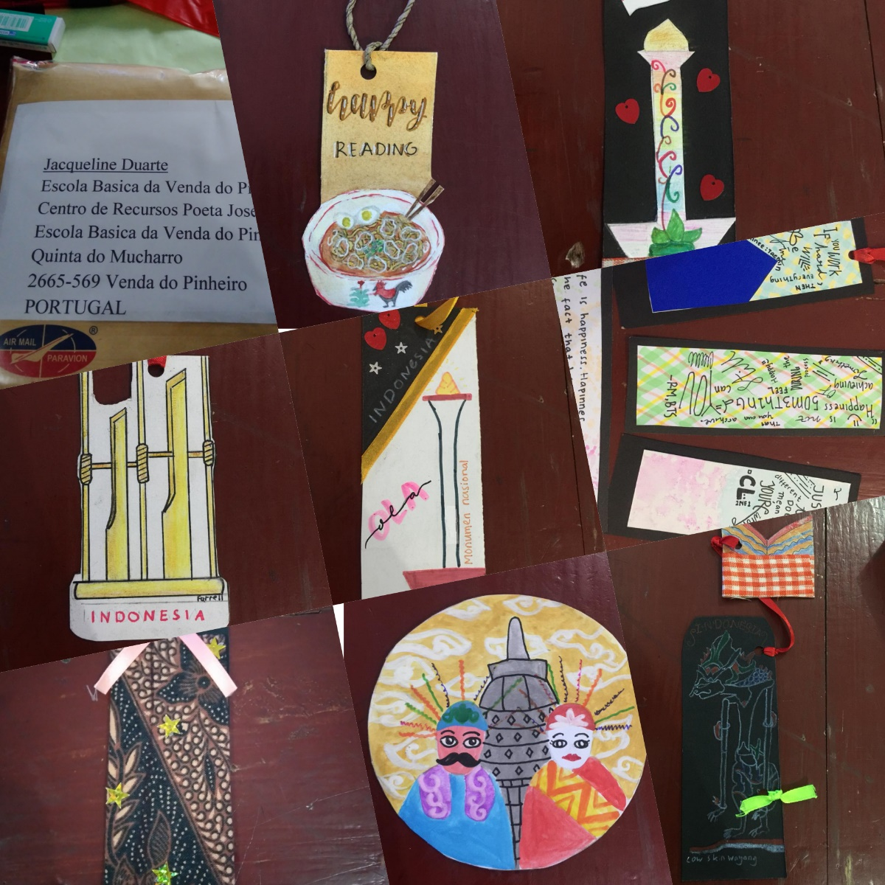

- Skype project
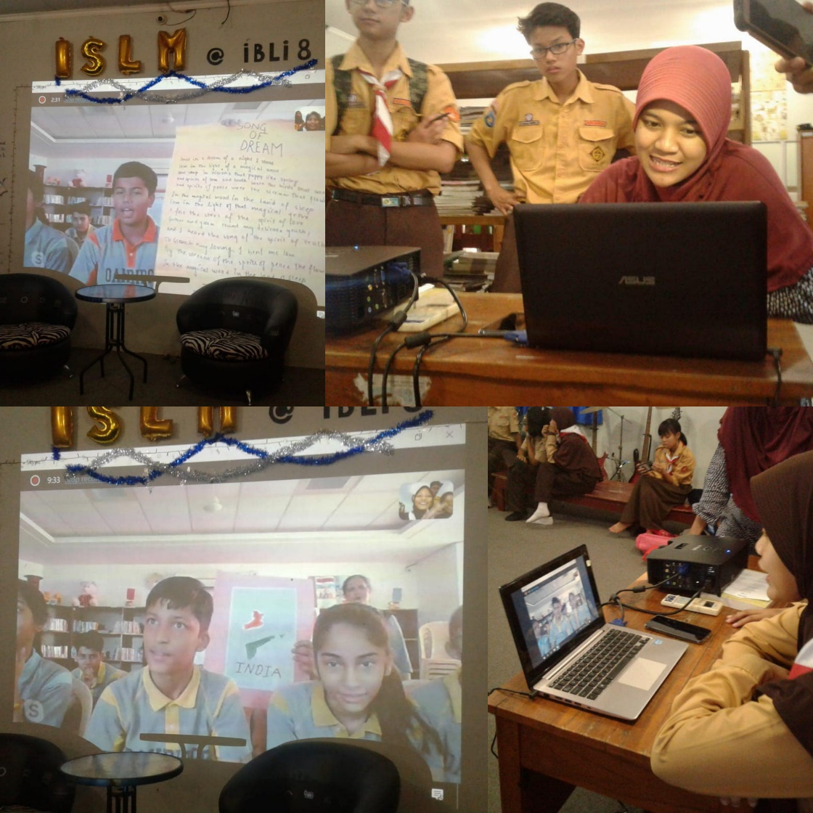

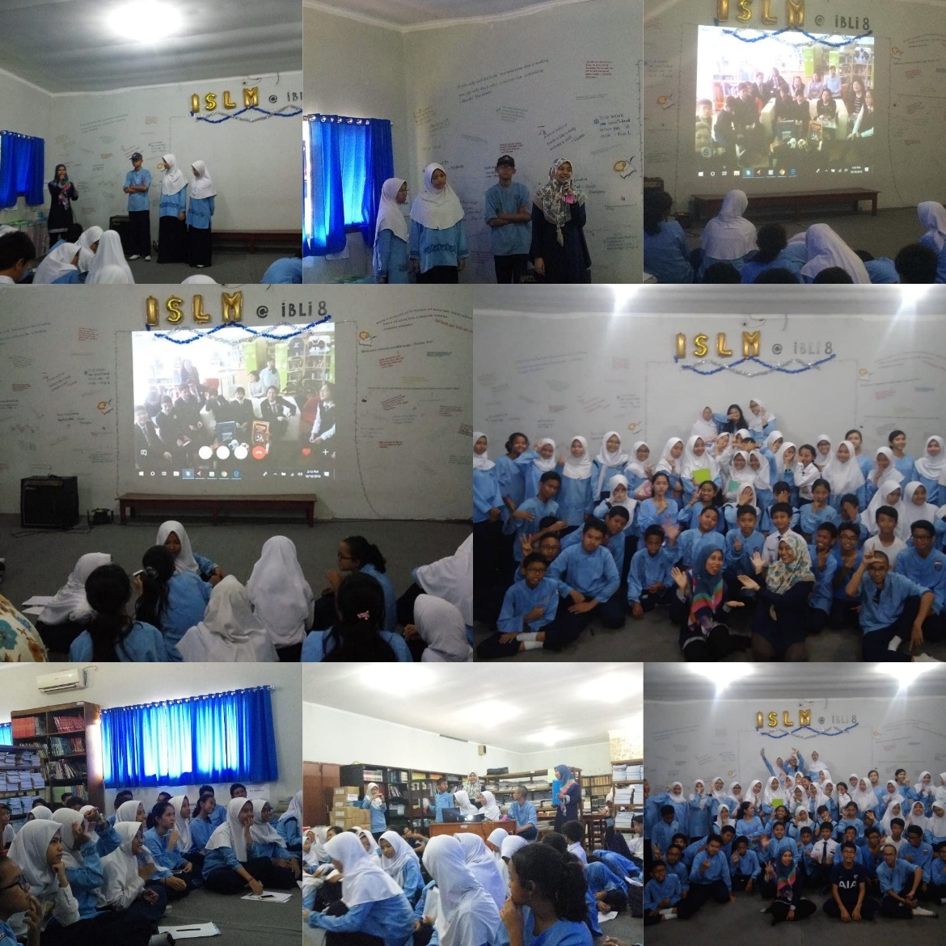

- Putar Film ( Movie Time)
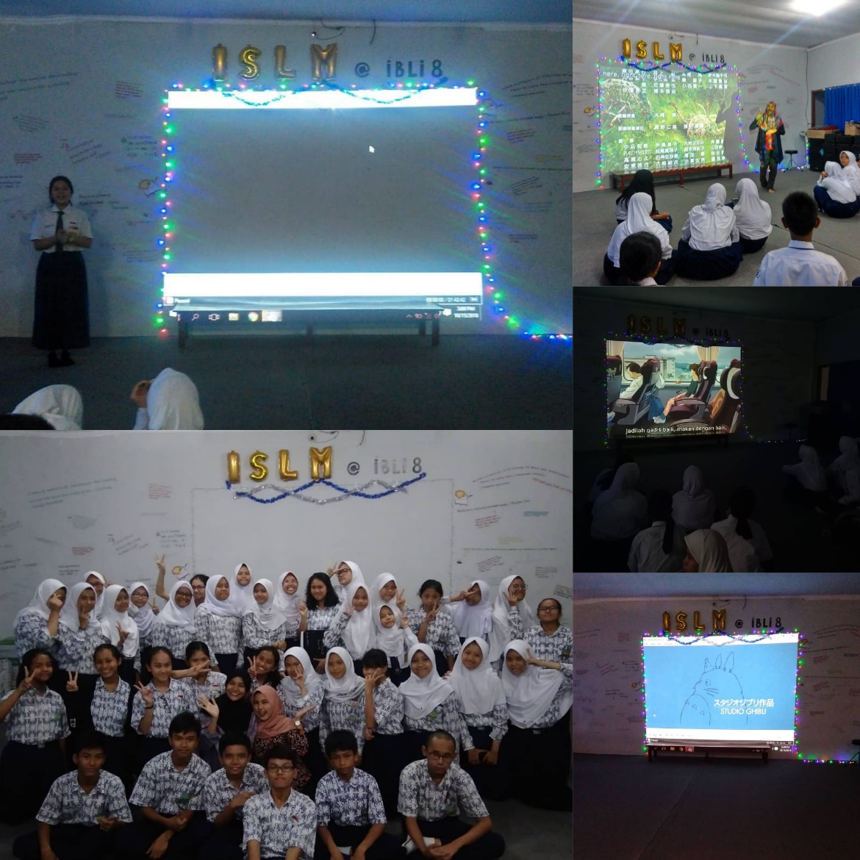

- Workshop Session , poster digital
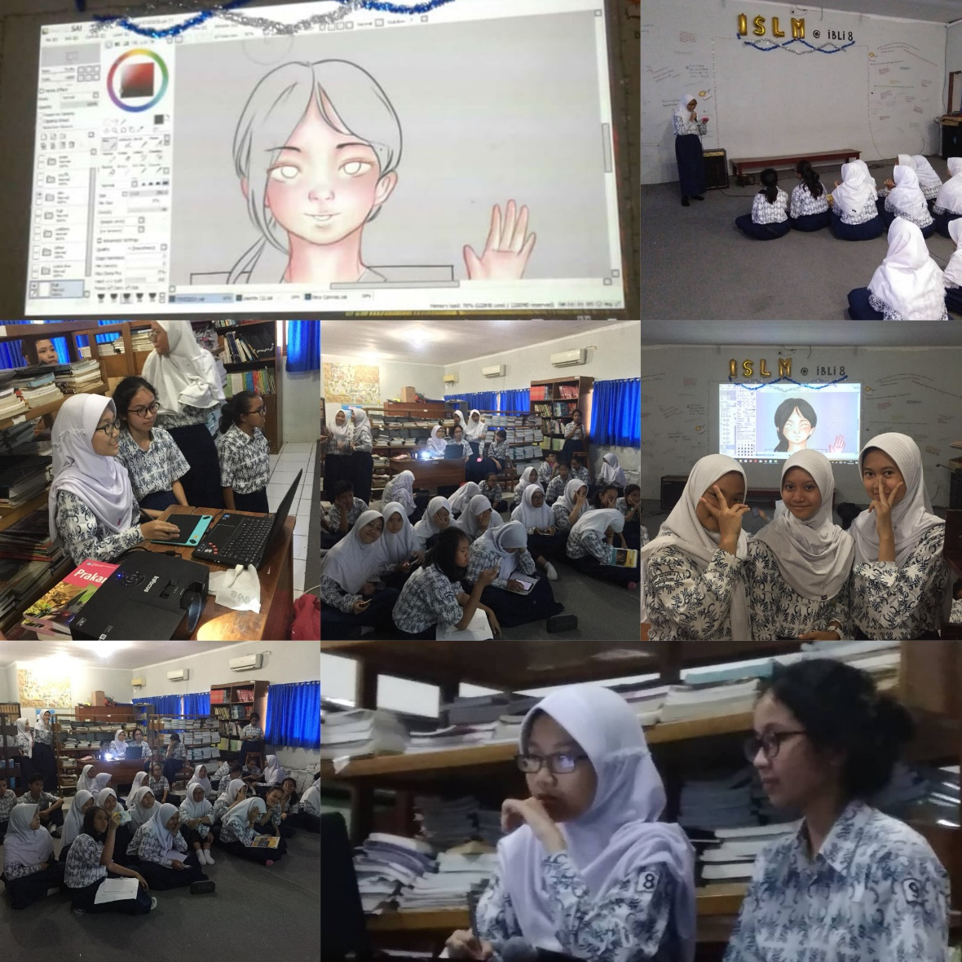

- Doodle competition
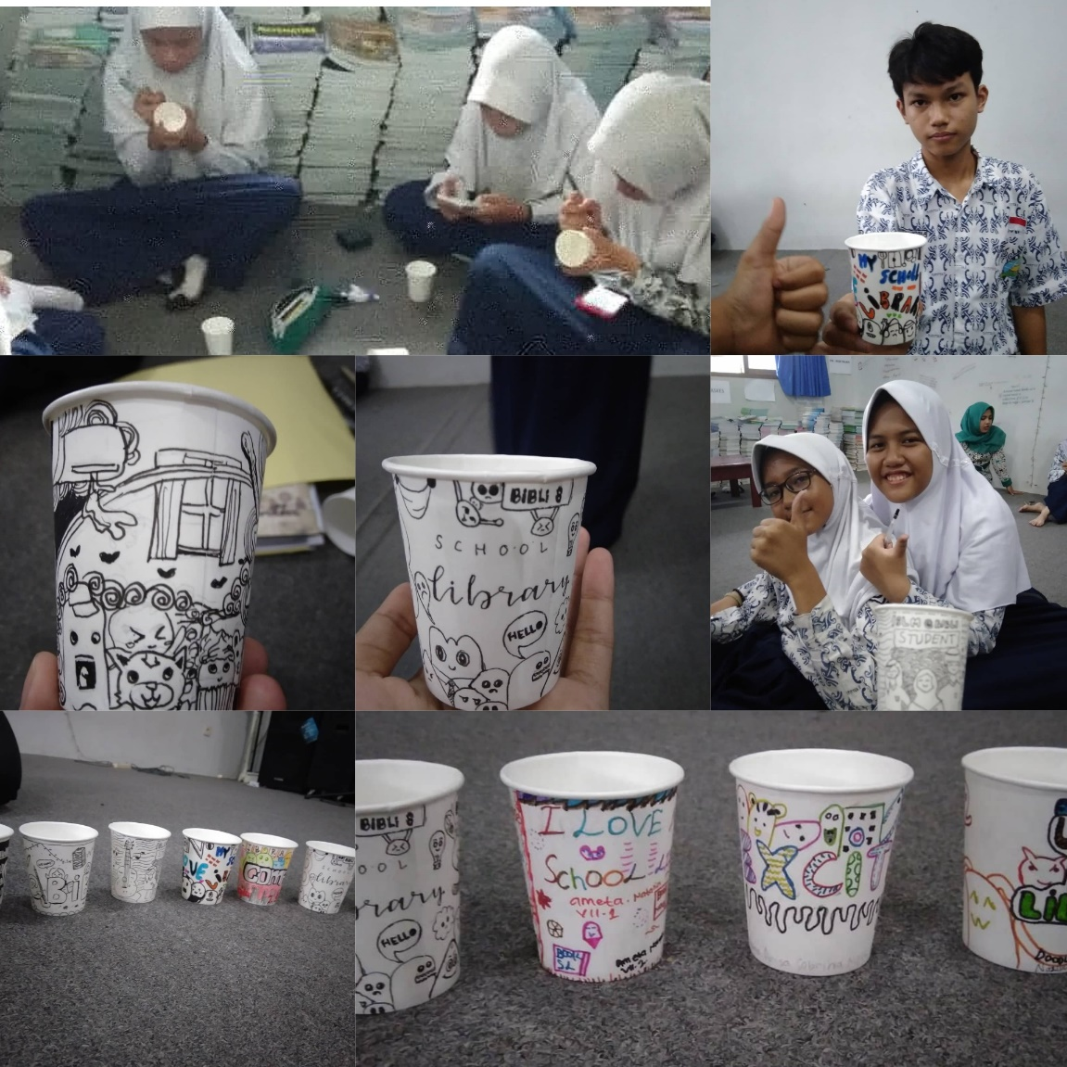

- Book tasting
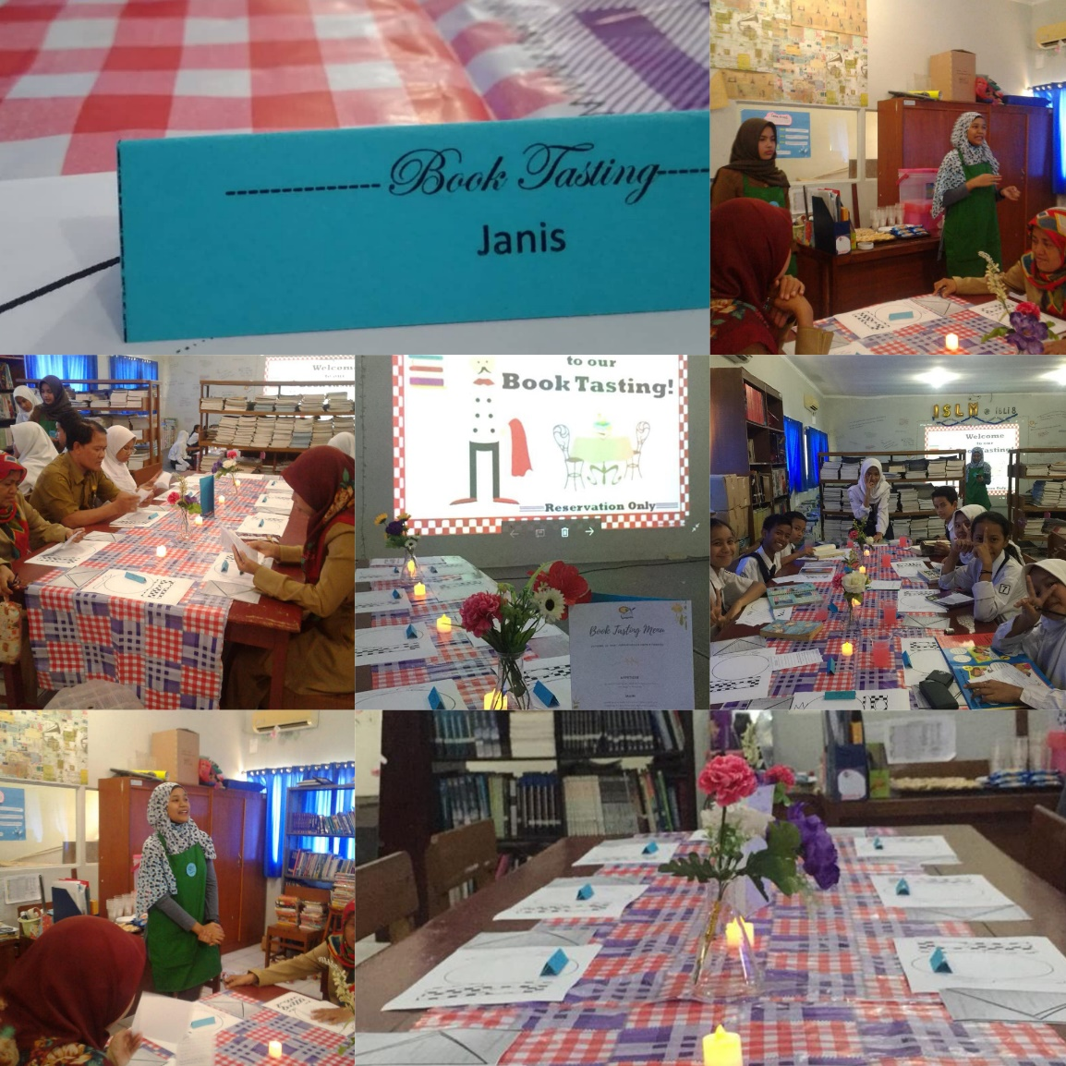

7. Inspiring Alumni
