Project Coordinator - Chingakham L Devi
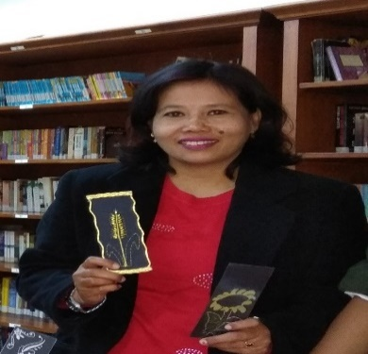
Country: India
Name of the School: Kasiga School, Dehradun, India
Website: www.kasigaschool.com

“A lamp can never light another lamp unless it continues to burn its own flame”. -- Rabindranath Tagore

INTERNATIONAL SCHOOL LIBRARY MONTH
Kasiga School Library has been successfully organising ISLM for the past five years and our students thoroughly enjoy all the activities associated with it. The purpose of organising International School Library Month in our school is to make the students aware of the importance of the school library where students are prepared for life and the process of learning. The theme of the ISLM is ‘Why I love my school library’.
‘I Love My School Library’ evinced great excitement all around the school library. ISLM project was fun filled month with children wherein the students participated in many activities to renew their love of books. The students enthusiastically participated in various activities and displayed their artistic and literary skills. An interesting quotes goes; “A good library is a joyful place where the imagination roams free, and life is enriched” which meant that students must consider their school library as a foundation for knowledge. Indeed a library is the greatest gift of all.
In this regard various activities were conducted in the school library to enhance the skills of the students which included:
- Bookmarks Designing, Book Cover Designing
- Book Review, Information Literacy
- Map activities, Flag project, Guess the authors, Harry Potter project
- Vocabulary Game (Prefixes: Make a New Word) (Class-III and IV)
- Name the Famous Monuments from the Six out of Seven Continents
- Quiz on Gandhi, Skype project

One of the key highlights of the project has been the book mark project which was done by the Junior and Middle School and the book marks will be exchanged across school libraries. We are sharing our Book Marks Project with schools from other parts of the globe. We have got partnership to swap our Bookmarks for Junior School with Osnovna Skola Drinje, Croatia, Debreceni Vorosmarty Mlhaly Altalanos, Hungary and Tiara Permai Primary School, Malaysia.
Middle School partnership included participating schools from Osnovna Skola Meje, Croatia and Scoala, Toma, Cocisiu, Romania. Students of junior and middle school made Book-Marks on ‘why I love my school library’ themes such as favourite story characters and thoughts of Great Personalities.
MOVIE SESSIONS- Students watched Oliver Twist, Rumplestiltskin, Jack and the Beanstalk and The Wizard of Oz.
BOOK REVIEW: Book review writing was conducted under the week long library month celebrations. The students from junior and middle school participated with great enthusiasm, thereby excelling & exhibiting their creative writing skills, which took them into the imaginary world of certain characters like Harry Potter, Cinderella, Tom Sawyer, etc. and further sharing their written expressions in English.

Global Skype Project: As a part of the ISLM, a Skype conference was conducted between Kasiga School and “Tiara Permai Primary School”, Kuala Lumpur, Malaysia during the library class which was coordinated by Ms Ranjana. All the students in the conference were eager and enthusiastic to know about each other’s language, culture, sports, etc. During the exchange that took place, the students of Kasiga School proudly proclaimed their school to be a centre of world cultural unity with students and teachers of different countries, religion and race living together and learning from each other. The students spoke about the school and their Library. They discussed about the different types of books and the authors which they enjoyed reading in the library. The children mentioned the library to be a joyous place which took them into the imaginary world of certain characters like Harry Potter, the books of Charles Dickens, etc.

Book Fair: Books are uniquely portable magic. Book fair are appetizer for further reading. Book fairs play a huge role in encouraging reading habit among people of all age groups. Working on the theme, ‘I love my Library’, under the aegis of International School Library Month, the Kasiga School, organized a book fair. The fair was inaugurated by the school Principal Ms. Sonali Sinha.

Once again I as the Head Librarian of Kasiga School would reinforce the fact that ISLM proved to be drawing huge interests amongst the kids of various grades and hope to come out with more vibrant and enjoyable programme. Thanking You.

