A Case Study of the Exchange Learning Program Established Within Three Elementary Schools Using Video Conferencing Systems
大平 睦美（ Ohira Mutsumi）
京都産業大学 (KYOTO SUNGYO UNIVERSITY)
This program was established in 2013.
The System enables the students to deliver their presentations and exchange ideas, while taking into account the environment and circumstances of the local community, school, and student.
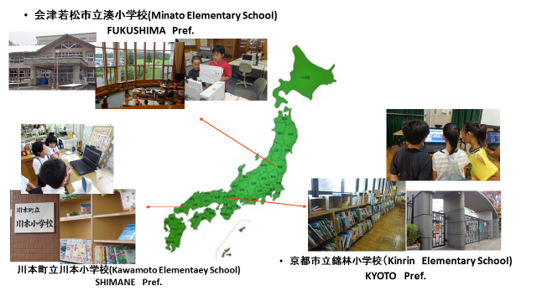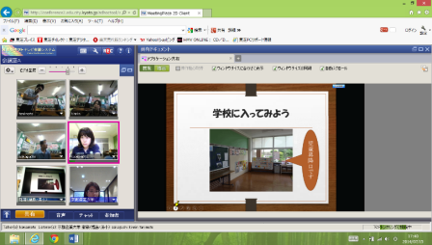
How did the teachers benefit?

Thanks to this program, individual teacher’s educational programs improved and as such, their students improved their information literacy skills.
５ grade Students
Kinrin（KYOTO）88
Kawamoto（SHIMANE）23
Minato（FUKUSHIMA） 12
We use 40computers

The students who participated all said that they wanted to take part in the program again and a resounding number said they had fun and enjoyed themselves in the learning environment.

（ VIDEO CONFERENCING SYSTEM）
The purpose of the Exchange Learning Program was to develop the interactive learning program in the ‘problem pursuing style’, which enabled students to be actively involved in learning
Questions and Answers for the Exchange Learning Program

